A skill-constrained human-in-the-loop research agent for rigorous paleomicrobiome data analysis
Author names to be completed
Affiliations to be completed
# These authors contributed equally, if applicable.
*Correspondence should be addressed to: [corresponding author email]
Keywords: paleomicrobiome; ancient DNA; human-in-the-loop agent; workflow validation; source-data verification; reproducible bioinformatics

Abstract
Paleomicrobiome and ancient-DNA studies increasingly reuse heterogeneous public files, supplementary tables, and repository metadata, yet many consequential errors arise before biological interpretation begins. Incorrect source files, inconsistent mate pairing, silent format mismatches, missing software environments, and unrecorded intermediate outputs can weaken downstream claims, especially for low-biomass and contamination-sensitive materials. We therefore developed a skill-constrained human-in-the-loop research agent as a rigor-enforcing front end for ancient-data analysis rather than an autonomous biological interpreter. The agent converts expert natural-language requests into structured local workflows, validates input references and file compatibility before execution, routes approved steps to predefined bioinformatics skills, and exports both final outputs and step-level audit records. This design separates planning, executable tool use, provenance checking, and expert interpretation. We evaluated the prototype through engineering checks and three representative validation tasks spanning tabular peptide curation, public FASTQ source-data verification, and a retraction-associated source-data audit. The agent blocked invalid workflow references before execution, curated a 5,810-row peptide validation table into 5,696 non-redundant records, reproduced read-count and compressed-file metadata across six public FASTQ records, and generated an auditable source-level report for SRR29088443 without evaluating the associated retracted biological conclusion. These results show that the main value of the agent is not automation of a single small analysis, but an inspectable control layer for fragile paleomicrobiome workflows. By making provenance, workflow validity, local execution, intermediate evidence, and interpretation boundaries visible, such agents may help domain experts conduct more reproducible early-stage analyses while preserving human responsibility for biological claims.

Key points
- The system frames rigorous paleomicrobiome analysis as a set of auditable controls over provenance, file integrity, workflow compatibility, output traceability, and interpretation boundaries.
- The language model proposes workflows, but predefined skills, validators, local tools, and expert checkpoints control execution.
- Engineering evaluation focused on whether those rigor controls could be enforced before downstream biological interpretation.
- Dataset-level demonstrations included peptide CSV curation, sequencing source-data verification, and a retraction-associated source-data audit.

Graphical abstract
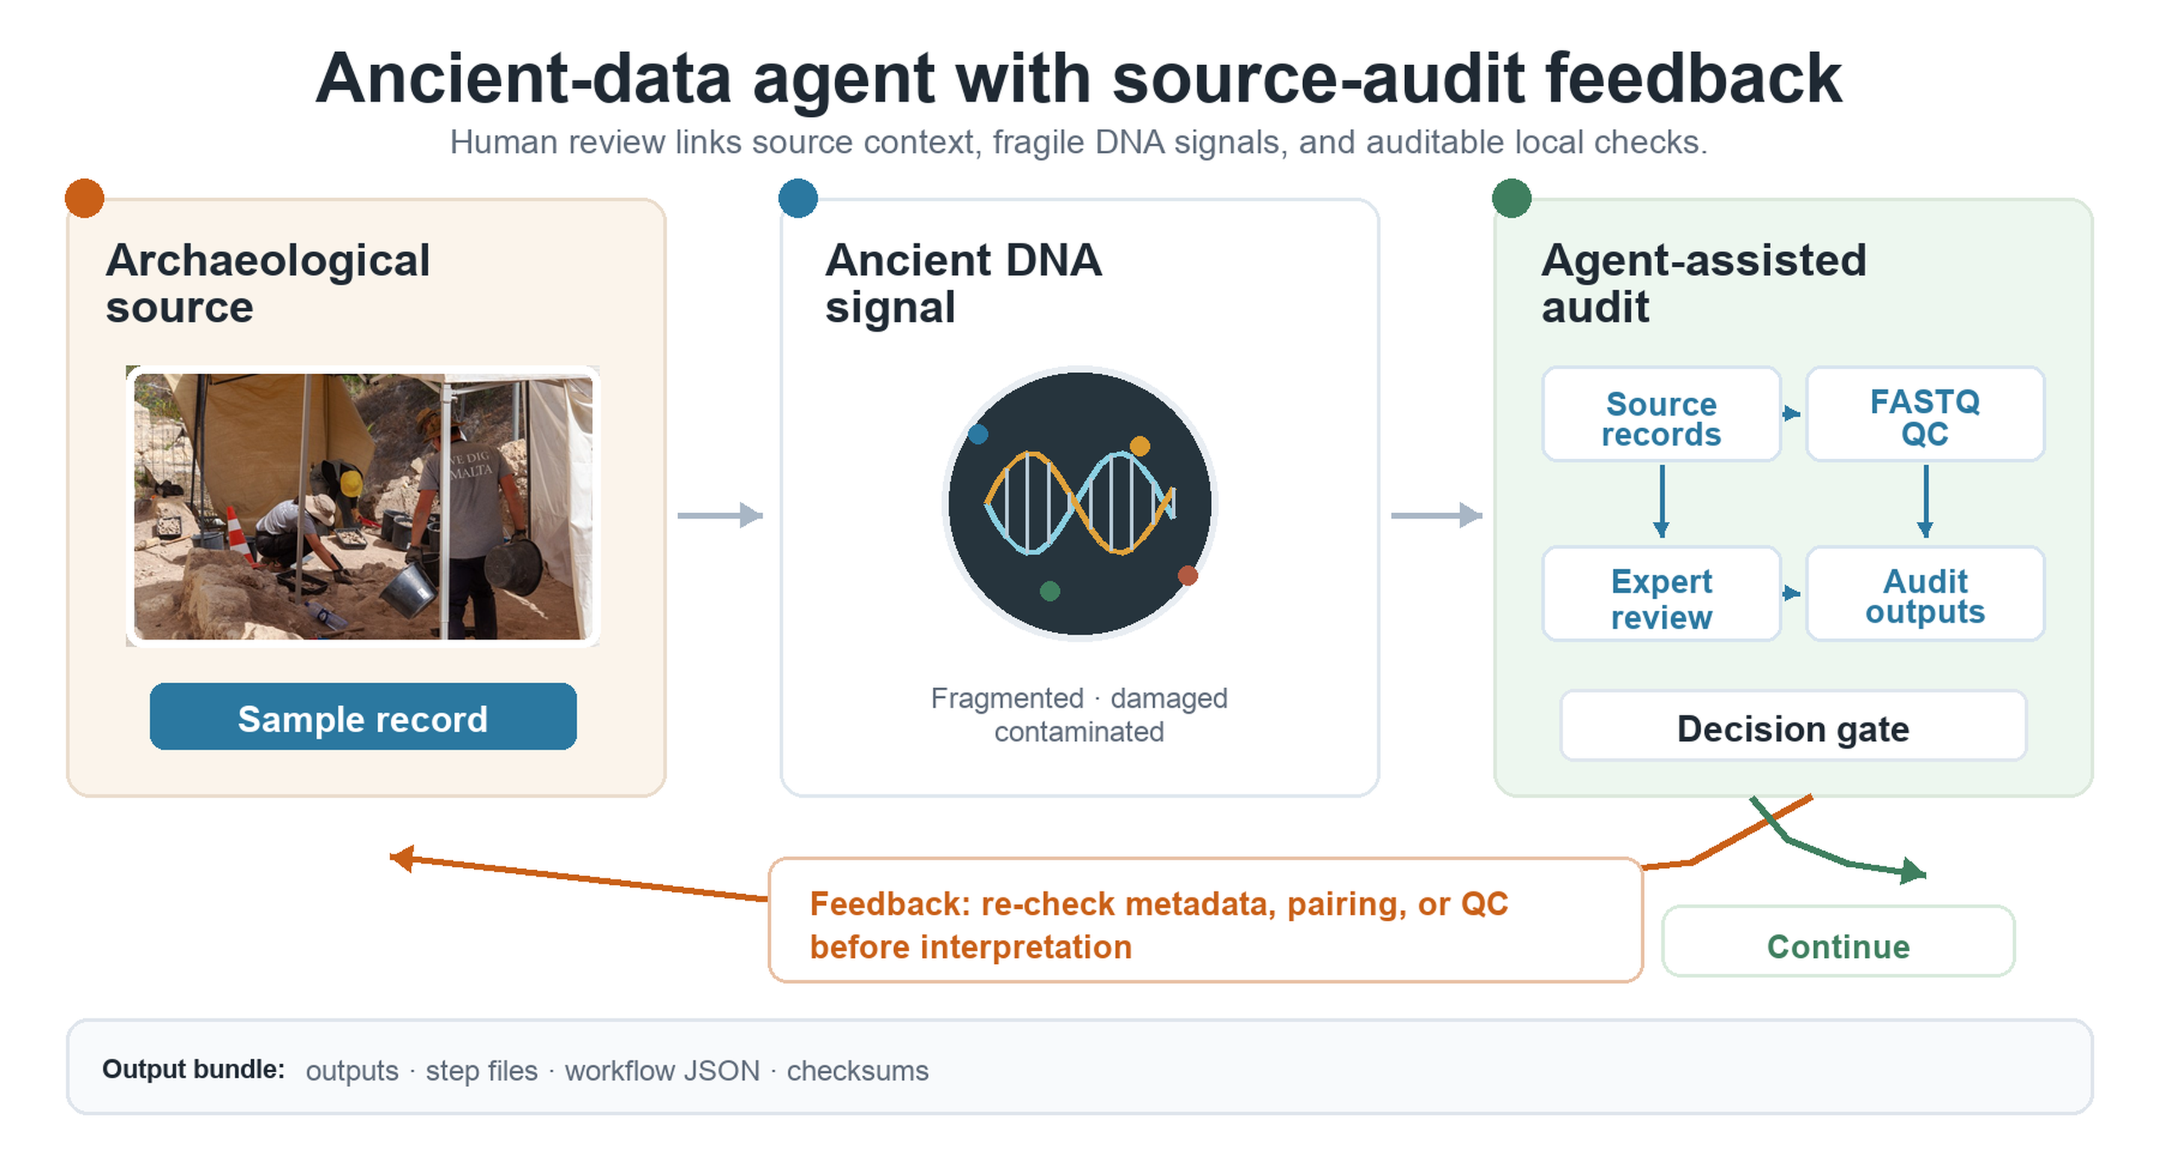
Graphical abstract. The agent is designed as a practical interface between archaeological source material, fragile ancient-DNA signals, and auditable local source-data checks for ancient human microbiome and paleomicrobiome analysis. Archaeological excavation photograph adapted from Godwin Borg, Wikimedia Commons, CC BY-SA 4.0; remaining schematic elements were created by the authors.

Introduction
Ancient human microbiome and paleomicrobiome research increasingly depends on heterogeneous public data. These data include sequencing reads, repository accession records, and supplementary biological tables (Leinonen et al., 2011; O’Cathail et al., 2025; Warinner et al., 2017). Although these resources are often available in principle, rigorous analysis remains difficult in practice. Researchers must identify the correct files, confirm that local downloads match public records, inspect file formats, run specialized tools, and retain intermediate outputs for later review. The practical challenge is therefore not only data access. It is the ability to transform heterogeneous source material into controlled analyses in which provenance, file integrity, workflow compatibility, and interpretation limits can be checked by another expert. This framing is consistent with broader principles for FAIR data stewardship and reproducible computational workflows (Di Tommaso et al., 2017; Köster & Rahmann, 2012; Sandve et al., 2013; Wilkinson et al., 2016).
This requirement is especially important for ancient-data research. Ancient DNA and paleomicrobiome materials are commonly low-input, degraded, fragmented, contamination-sensitive, and dependent on strict provenance (Briggs et al., 2007; Cooper & Poinar, 2000; Dabney et al., 2013; Gilbert et al., 2005; Pääbo, 1985; Skoglund et al., 2014; Warinner et al., 2017). Early failures can compromise downstream mapping, damage profiling, taxonomic assignment, contamination assessment, and authentication (Dabney et al., 2013; Jónsson et al., 2013; Schubert et al., 2012). Examples include incomplete downloads, malformed sequencing records, incorrect mate or run grouping, and unreported read-count differences. The specific metadata fields and file-pairing rules vary across sequencing designs. The underlying requirement is stable: source identity and file integrity must be checked before interpretation. These checks require professional judgment even when the commands themselves are routine.
A rigorous paleomicrobiome workflow should therefore expose these early decisions rather than hide them inside a successful terminal command. For a tool-oriented study, the central question is not only whether an agent can run a command. It is whether the agent makes the chain from source record to local output explicit enough for domain experts to challenge, repeat, or reject.
Large language models offer a promising natural-language interface for lowering operational barriers, but unrestricted code generation is not sufficient for reproducible scientific analysis. A model may invent file names, reference outputs that do not exist, apply FASTQ tools to CSV files, or assume unavailable environments. In ancient-data workflows, these errors are not merely inconvenient; they can obscure whether a downstream result reflects biology, file handling, or a planning mistake. Tool-using language-model agents can make reasoning and action more inspectable, but scientific workflows still require external constraints, provenance checks, and expert review (Yao et al., 2022).
We therefore developed a skill-constrained human-in-the-loop research agent for rigorous paleomicrobiome data analysis. The system uses the language model for workflow proposal, but delegates execution to predefined skills and local tools only after workflow validation. Human experts remain involved at three points: reviewing the generated workflow, approving local execution, and interpreting final reports. This design is intended to preserve the flexibility of natural-language interaction while maintaining explicit controls around data provenance, file compatibility, output traceability, and claim boundaries. In this manuscript, we treat rigor as an operational property of the analysis workflow. A result is more reviewable when the source record, local file, requested operation, generated output, and interpretive scope can each be inspected independently.
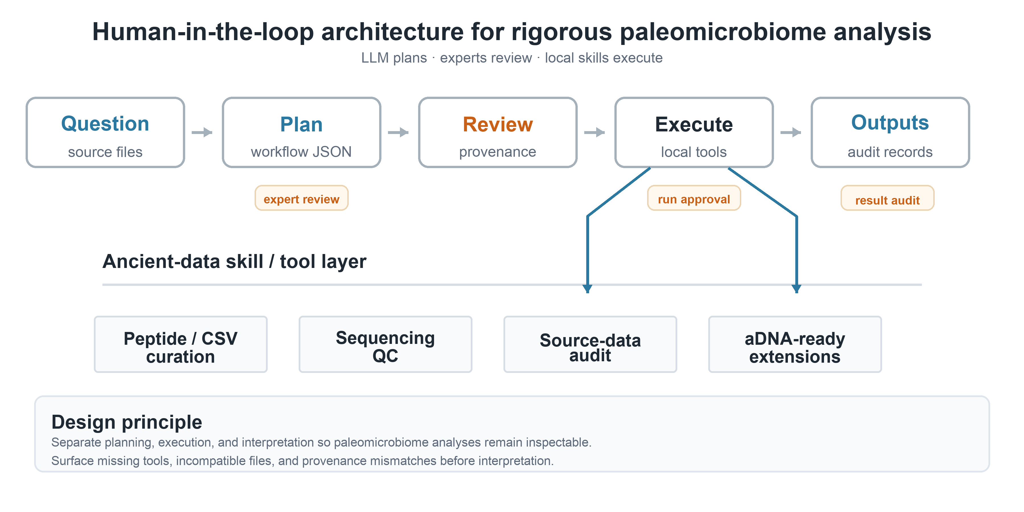
Figure 1. Human-in-the-loop architecture of the ancient-data research agent. The workflow starts from an expert natural-language request and source files, including peptide or metadata CSV tables, sequencing files, and repository records. The language model drafts a structured analysis plan, but domain experts review provenance, input organization, task compatibility, and parameter choices before local execution. Approved skills then perform ancient-data curation, sequencing quality control, source-record audits, and other reproducible analysis steps. Final outputs are separated from intermediate step files. Audit records preserve the workflow JSON, file checksums, tool reports, and execution history for later inspection and reuse.

Results

System-level workflow control enabled inspectable analysis planning
We first evaluated the agent as an engineering system rather than as a set of independent case studies. Each user request was converted into a structured workflow containing ordered steps, skill names, input references, parameters, expected outputs, and reasons for each operation. This representation made the analysis plan inspectable before execution. It also allowed a validator to test whether later steps referred to valid earlier outputs and whether the proposed skill was compatible with the uploaded file type.
This design directly addressed common failure modes observed during development. Invalid workflows were most often caused by ambiguous natural-language prompts, incorrect source-file references, incompatible file formats, or hallucinated step-output names. The validator converted these failure modes into visible errors rather than allowing the local execution stage to fail silently. The resulting system therefore positioned the language model as a planner, not as an uncontrolled executor.

Table 1. Agent control layers and expert checkpoints. The table summarizes how planning, validation, execution, output organization, and interpretation are separated so that the system can support paleomicrobiome analysis without replacing domain-expert judgment.
Layer | Risk addressed | Control used | Expert intervention
Planner | Ambiguous user intent | Structured workflow JSON | Review proposed steps before running
Validator | Missing outputs or wrong file type | Reference and compatibility checks | Reject or revise invalid workflow
Executor | Uncontrolled code generation | Predefined skills and local tools | Approve local execution
Reporter | Opaque outputs | Final files, step files, records and checksums | Interpret results and boundaries

Engineering controls operationalized paleomicrobiome analysis rigor
The agent was evaluated using engineering criteria that are important for ancient-data analysis: workflow validity, input-format compatibility, source metadata agreement, output traceability, and transparent handling of missing software environments. We used these criteria as operational markers of rigorous paleomicrobiome analysis because they test whether a computational result can be reviewed and repeated before any biological interpretation is made. This framing separates source-data verification from biological validation. Source-data verification asks whether the intended input was processed in a traceable way. Biological validation asks whether the inferred microbial signal is authentic, uncontaminated, and biologically meaningful.
For sequencing inputs, we treated repository identifiers, run layout, read counts, file sizes, and related metadata as reproducibility details rather than as the main biological result. The most direct source-level checks were read-count agreement and file-size agreement between local files and public ENA/SRA records. Derived QC values such as GC content and mean read length were reported as descriptive outputs. This distinction limited the scope of the agent's claim. Source-level agreement indicates that the intended records were processed in a traceable way. It does not transfer biological interpretation from domain experts to the agent.

Table 2. Engineering evaluation criteria used to assess workflow rigor. Each criterion corresponds to a failure mode observed during development and defines how the agent was expected to prevent or expose the problem before biological interpretation.
Evaluation target | Metric or rule | Interpretation
Workflow validity | All step inputs must reference uploaded files or earlier outputs | Prevents hallucinated pipeline references
File compatibility | Input format must match skill requirements | Prevents applying FASTQ operations to CSV files
Source agreement | Δreads = 0 and Rbytes = 1 when public metadata are available | Confirms local files match repository records
Traceability | Final outputs plus step outputs and run records | Allows later inspection by users or supervisors
Dependency behavior | Missing tools are reported instead of auto-installed | Keeps execution transparent on user machines

Quantified engineering comparison with existing workflow paradigms
Before presenting dataset-level demonstrations, we treated workflow control itself as a semi-quantitative benchmark. The comparison did not ask whether the prototype outperformed complete external bioinformatics pipelines in biological accuracy or runtime. Instead, it asked whether four common analysis modes, manual command-line work, fixed pipelines, unconstrained language-model code generation, and the proposed skill-constrained agent, expose the controls needed for paleomicrobiome source-data reuse. The evaluated properties were whether the analysis plan is inspectable before execution, whether file type and step-output references are validated, whether public source records can be compared with local files, whether intermediate outputs are retained, and whether claim-level interpretation remains separated from source-level checks.

Table 3. Quantified engineering comparison of workflow-control properties. The table links common limitations of existing analysis modes to measurable outcomes produced by the agent in the validation tasks.
Workflow-control property | Measured agent outcome | Comparison interpretation
Planning validity | Workflows were represented as explicit ordered steps with declared inputs, outputs, parameters, and validation rules before local execution. | Unlike manual command lines or unconstrained LLM code, the plan is inspectable before anything runs.
Tabular biological data curation | The peptide validation table was curated from 5,810 rows to 5,696 non-redundant records; 114 duplicate sequence entries were removed. | The result is not only a cleaned table, but a recorded transformation with reusable outputs.
Public FASTQ source-data verification | Across six public FASTQ records, agent-derived read counts matched ENA/SRA metadata with Δreads = 0, and compressed-file ratios were Rbytes = 1.000. | The system quantifies whether local files match intended public records before downstream interpretation.
Retraction-associated source audit | For SRR29088443, the agent generated an auditable source-level report while limiting interpretation to file-level reproducibility. | The audit separates source-data reproducibility from disputed or retracted biological claims.
Output traceability | Each local run exports final_outputs, step_outputs, and ResearchAgent Records containing workflow JSON, manifests, checksums, timestamps, and run reports. | The evidence chain can be reviewed later by users, supervisors, or domain experts.
This comparison positions the system as a measurable workflow-control layer rather than an autonomous biological interpreter. The benchmark is therefore deliberately operational: it quantifies auditability, traceability, and boundary control using observed workflow outputs, while leaving biological authenticity and downstream scientific interpretation to established domain methods and expert review. The following case studies evaluate whether these controls preserve traceability, file compatibility, and reviewable outputs across representative tabular and sequencing inputs.

Case study 1: peptide CSV curation verified tabular skill behavior
As a lightweight tabular case, we tested a headerless peptide validation CSV containing 5,810 rows. The agent normalized the input into canonical label and sequence columns, validated peptide sequences, removed duplicate entries, calculated descriptive summaries, generated plots, and exported a cleaned CSV. The workflow produced 5,696 non-redundant peptide records and removed 114 duplicate sequence entries.
This case tested whether the agent could handle ambiguous biological tables without manual spreadsheet editing. The output preserved the expected label structure and peptide-length distribution while producing a reusable cleaned table. Because peptide analysis is only one possible application, this result is presented as a skill-behavior check rather than as the central biological contribution of the system.
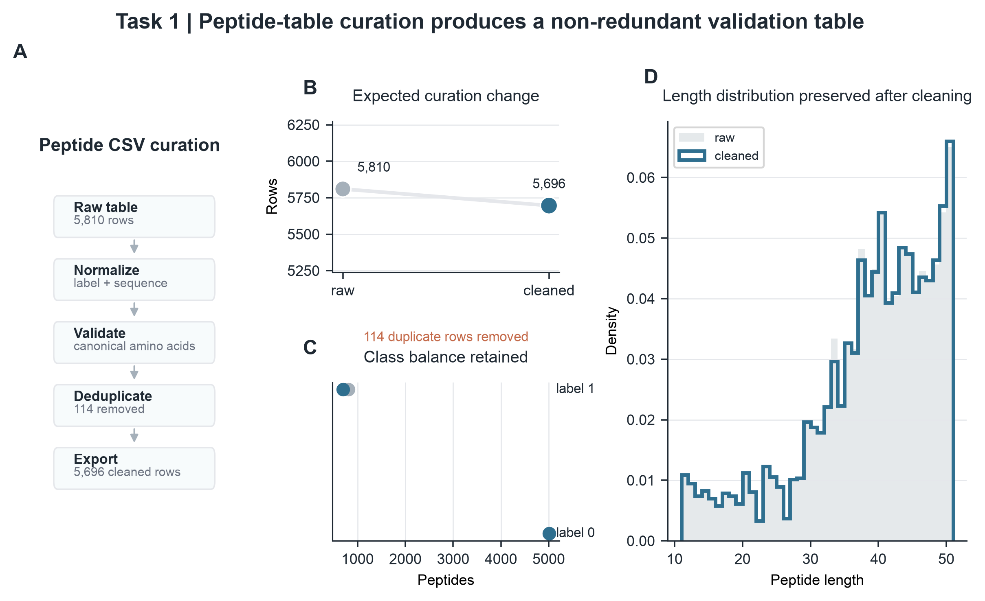
Figure 2. Peptide CSV curation. A, Natural-language peptide-table processing workflow. B, Row-count change after duplicate removal. C, Label balance before and after cleaning. D, Peptide-length distribution after curation.

Case study 2: sequencing source-data checks verified traceable input handling
We then evaluated six public sequencing records relevant to ancient or paleomicrobiome source-data reuse. The agent performed file inspection, quality-control summarization, seqkit-based statistics, and metadata comparison against ENA/SRA records (Andrews, n.d.; Ewels et al., 2016; Leinonen et al., 2011; O’Cathail et al., 2025; Shen et al., 2016). Accession numbers and library-layout fields were retained in the audit trail to support reproducibility. The case study was designed to test whether the workflow could check source identity and file integrity across records, not to privilege any single sequencing configuration. Across all six records, agent-derived read counts matched the corresponding public records with Δreads = 0. Local compressed file sizes also matched public fastq_bytes values, giving Rbytes = 1.000 for all tested inputs. The tested files ranged from 56,122 to 4,380,359 reads.
These results show that the agent can check whether local sequencing files correspond to the intended public records before downstream analysis. For ancient DNA and paleomicrobiome work, this is a necessary front-end control. Incorrect source files, incomplete downloads, or mismatched run organization can invalidate later alignment, taxonomic, or authentication analyses even when downstream tools run successfully (Dabney et al., 2013; Jónsson et al., 2013; Warinner et al., 2017). The same principle applies across sequencing strategies. Run-specific details should be documented clearly, but the central contribution is the auditable control of source-data handling.
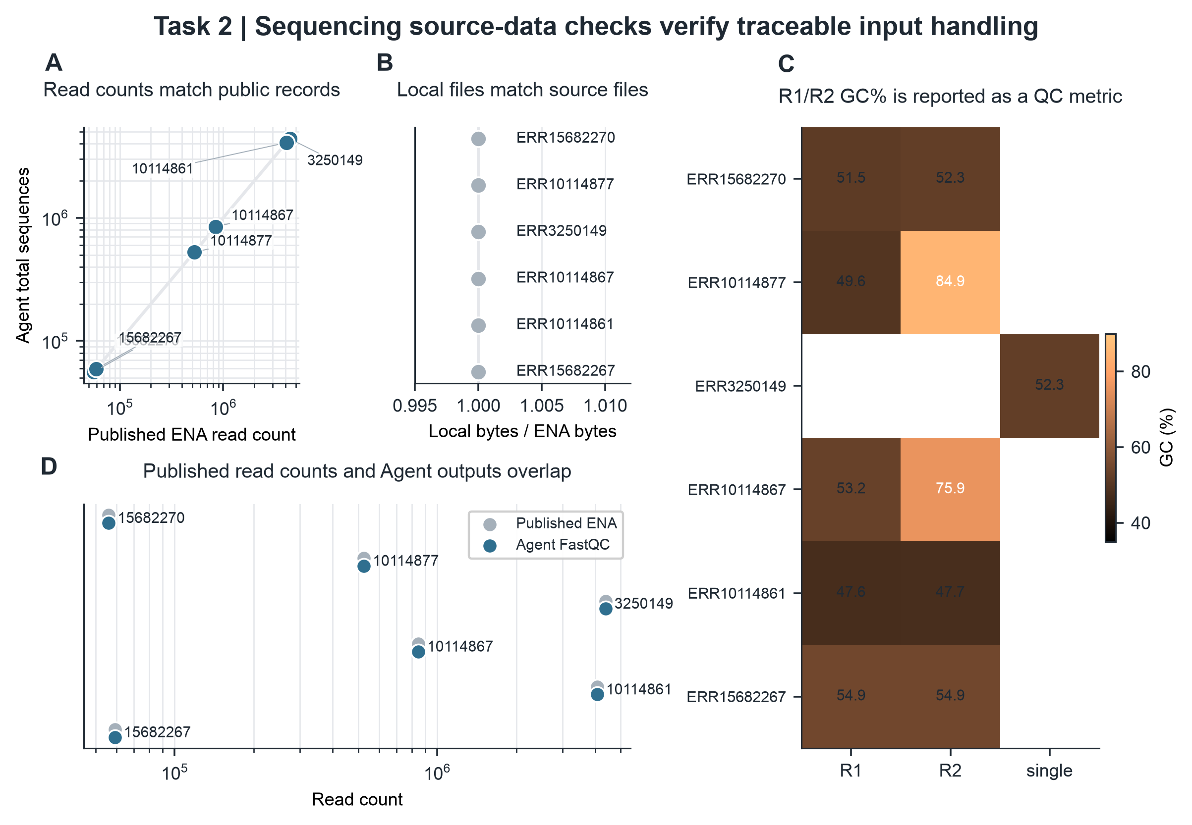
Figure 3. Sequencing source-data verification. A, Agent-derived read counts compared with public ENA/SRA read counts. B, Local compressed file sizes compared with public fastq_bytes values. C, GC content reported as a derived QC metric. D, Source-record agreement summarized across the tested files.

Case study 3: boundary-aware audit of a retraction-associated record
The third case tested whether the agent could remain useful in a high-risk literature setting rather than merely process another FASTQ file. We selected one public accession from SRP508771 because the associated publication record is linked to a retraction (Gao et al., 2024, 2026). The accession SRR29088443 was therefore used as a boundary-stress test: the agent was expected to verify what is reproducible at the source-data level, while explicitly avoiding any attempt to rescue or reinterpret the disputed biological conclusion.
This boundary-aware audit succeeded at the level it was designed to test. The agent identified the paired FASTQ files, preserved the public accession metadata, and reproduced the repository-level values exactly. Both mates contained 53,571 reads, the combined base count was 26,517,645 bp, and the compressed file sizes matched the public record for R1 and R2. It also generated independent QC outputs from the same files, including mean read lengths of 244 bp and 251 bp, GC contents of 54.0% and 53.6%, and zero malformed records. The important result is therefore not a biological validation of a retracted claim, but a stronger operational point: the agent can turn a problematic literature record into an auditable, source-level reproducibility check and make the interpretation boundary visible to the expert user.
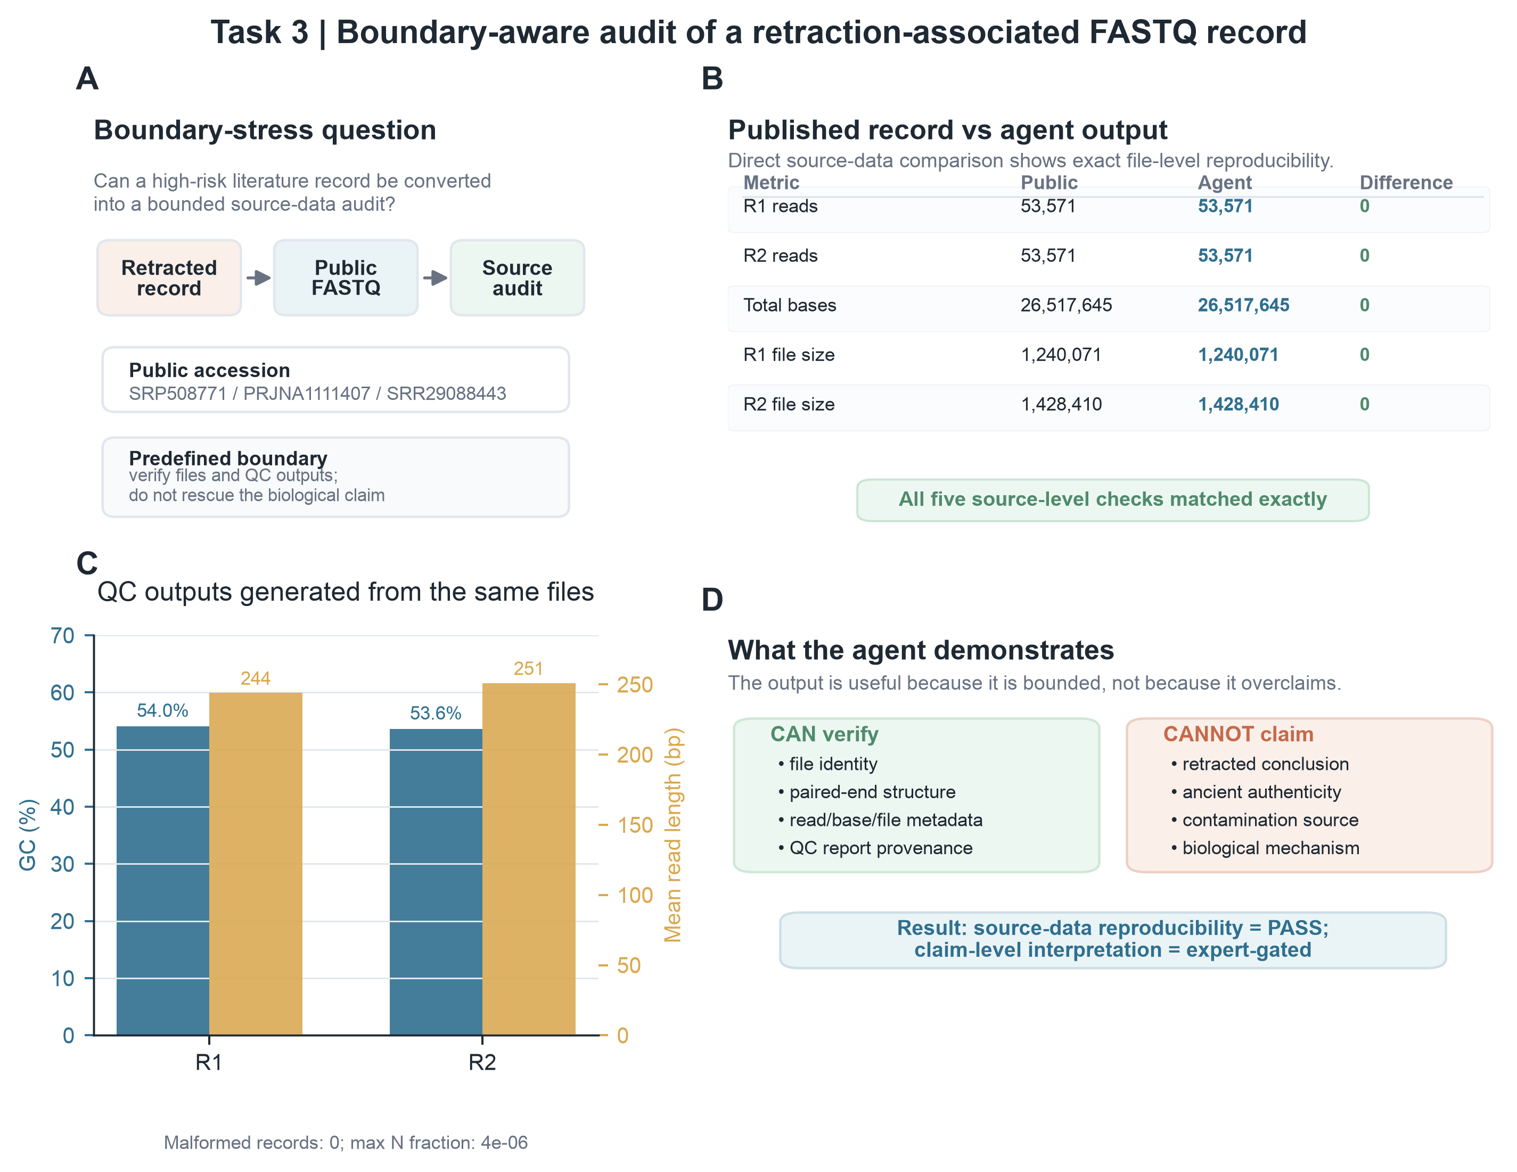
Figure 4. Boundary-aware audit of a retraction-associated FASTQ record. A, The case was framed as a boundary-stress question rather than as a biological validation task. B, Direct comparison between public repository metadata and agent-derived outputs showed exact agreement for R1 reads, R2 reads, total bases, and compressed file sizes. C, The same source files were used to generate QC outputs, including GC content, mean read length, malformed-record checks, and N-fraction checks. D, The audit separates what the agent can verify—file identity, paired-end structure, metadata agreement, and QC provenance—from what it cannot claim without expert interpretation, including the validity of the retracted biological conclusion.

Discussion
This study presents a prototype human-in-the-loop research agent for rigorous early-stage paleomicrobiome and ancient-data analysis. The central advance is a workflow-control layer that turns natural-language intent into validated, locally executed, and auditable steps. This contribution is narrower than a new ancient-DNA algorithm but important for practice: many errors in public-data reuse arise before biological interpretation begins, when source files, file types, software environments, intermediate outputs, or analysis boundaries are not inspectable (Dabney et al., 2013; Warinner et al., 2017).
First, the results suggest that natural-language agents are safer for scientific use when planning, validation, execution, and interpretation are separated. The model provides flexibility in translating user intent, but the executable actions are restricted to predefined skills and validated input-output references. This separation is especially relevant for paleomicrobiome work, where an apparently simple file-level operation may have different implications depending on preservation, contamination risk, laboratory history, and downstream authentication criteria.
Second, the prototype should be interpreted as an auditable front end rather than a complete ancient-DNA analysis platform. It supports file-level checks, tabular curation, quality-control report generation, source-record comparison, and evidence packaging. It does not replace host-removal pipelines, taxonomic profilers, duplicate marking, damage-pattern estimation, contamination modelling, or statistical interpretation (Jónsson et al., 2013; Schubert et al., 2016). Future skill extensions should therefore preserve the same boundary: the system may execute standardized operations, but experts must define the question, approve the workflow, and interpret biological meaning.
Third, a controlled contamination stress test would provide a stronger next benchmark than additional file-level demonstrations alone. Ancient human microbiome and paleomicrobiome datasets are vulnerable to mixtures of endogenous molecules, environmental microbes, modern handling contamination, and background laboratory signal (Davis et al., 2018; Eisenhofer et al., 2019; Karstens et al., 2019; Salter et al., 2014). A future benchmark could construct synthetic mixtures in which ancient-data-like reads are combined with soil-associated or laboratory-associated microbial reads at predefined proportions. The aim would not be to claim autonomous authentication. It would test whether the agent preserves provenance, reports contamination-sensitive summaries, records downstream tool outputs when available, and exposes the point where expert judgement must begin.
Fourth, the retraction-associated example should be expanded into a broader negative-control panel of retracted, contaminated, or contested ancient-DNA and paleomicrobiome studies. Such a panel should prioritize cases in which public sequence records remain available, but the biological interpretation has been challenged because of reagent contamination, environmental microbial intrusion, or insufficient authenticity controls (Adler et al., 2013; Davis et al., 2018; Eisenhofer et al., 2019; Karstens et al., 2019; Salter et al., 2014; Warinner et al., 2014, 2015, 2017; Weyrich et al., 2017). The expected behavior of the agent would be to reproduce auditable source-level checks, report provenance and QC evidence, and require domain-expert review before any claim-level conclusion is made.
Finally, practical usability depends on packaging the agent as a reproducible research object rather than only as a local prototype. The GitHub repository should include installation instructions, environment checks, example inputs, workflow JSON files, run reports, figure-generation scripts, source-data manifests, and a stable release tag. A hosted demonstration website or packaged local web application would improve accessibility for non-programming users, while local execution remains important for large sequencing files and sensitive research contexts. These infrastructure details are part of the scientific contribution because they determine whether experts can inspect, reproduce, and safely extend the workflow.

Limitations
This study evaluates a prototype rather than a complete ancient-DNA or paleomicrobiome analysis platform. The current system supports source-data checks, table curation, quality-control report generation, and traceable output organization, but it does not yet implement the full range of downstream analyses required for ancient-data authentication, including host removal, taxonomic profiling, duplicate marking, damage-pattern estimation, contamination modelling, or statistical interpretation. The evaluation used representative case studies rather than a large-scale benchmark across laboratories, sequencing strategies, and preservation contexts. Therefore, the results should be interpreted as evidence that the agent can improve workflow inspectability and source-level reproducibility, not as evidence that it can independently validate biological authenticity or contested claims. The system also depends on locally installed tools and the currently available skill library; missing software or unsupported tasks remain explicit limitations rather than silently handled capabilities.

Conclusion
We present a skill-constrained, human-in-the-loop research agent for rigorous paleomicrobiome and ancient-data analysis. By separating natural-language planning, workflow validation, local skill execution, output organization, and expert interpretation, the system turns common failure modes into inspectable checkpoints. Across tabular peptide data, public sequencing source records, and a retraction-associated audit case, the agent preserved source-level traceability while avoiding unsupported biological interpretation. This design suggests a practical route for making ancient-data analysis more accessible to non-programming researchers without weakening the expert review required for fragile, contamination-sensitive materials.

Methods

Agent workflow representation
A user request was represented as an ordered workflow W containing n executable steps:
W = {s₁, s₂, …, sₙ}
Each step sᵢ was defined by a skill identifier kᵢ, input references Iᵢ, output declarations Oᵢ, parameters θᵢ, and a natural-language reason rᵢ:
sᵢ = (kᵢ, Iᵢ, Oᵢ, θᵢ, rᵢ)
This representation made the planned analysis explicit before execution and allowed both automated validation and human review, aligning the agent with reproducible-workflow principles rather than treating the model output as an unstructured command transcript (Di Tommaso et al., 2017; Köster & Rahmann, 2012; Sandve et al., 2013; Wilkinson et al., 2016).

Workflow validation
The validator evaluated a proposed workflow W against the available uploaded files F and the available skill registry K:
V(W, F, K) → {0, 1}
A workflow was accepted only when it satisfied three conditions. First, every step had to use an available skill. Second, every input reference had to point to an uploaded file or an earlier step output. Third, every input format had to be compatible with the requested skill:
Iᵢ ⊆ F ∪ O<ᵢ
format(Iᵢ) ∈ compatible(kᵢ)
These checks were added because unconstrained planning produced errors such as missing step outputs, inconsistent reference syntax, and inappropriate decompression or FASTQ-QC operations for the selected file type.

Execution environment and implemented skills
Validated steps were dispatched to local skills. Implemented skills included peptide CSV normalization, peptide sequence validation, duplicate removal, CSV export, file-type detection, sequencing-file organization checks, FastQC execution, MultiQC report generation, seqkit statistics, and source-data audit utilities (Andrews, n.d.; Ewels et al., 2016; Leinonen et al., 2011; O’Cathail et al., 2025; Shen et al., 2016). External tools were called from configured local environments. If a required program was missing, the system returned an explicit missing-dependency message rather than installing software automatically.

Human-in-the-loop checkpoints
Human intervention was built into three checkpoints. First, the expert reviewed whether the generated workflow matched the scientific request. Second, the user approved local execution after inspecting the planned steps. Third, the user interpreted the final reports with access to intermediate step outputs and audit records. These checkpoints were designed to keep the agent useful for non-programming users without transferring scientific judgment to the model.

Scope and non-goals
The prototype was designed as a workflow-control and evidence-organization layer, not as an autonomous paleomicrobiome interpreter. It can check source-file identity, input compatibility, workflow references, quality-control outputs, run records, and provenance links. It does not independently authenticate ancient molecules, identify the origin of contamination, infer microbial ecology, validate retracted biological claims, or decide whether a downstream evolutionary, clinical, or archaeological interpretation is correct. Those tasks require domain-specific methods, laboratory context, negative controls, and expert judgement. This boundary is central to the system design because source-data reproducibility can be established even when biological interpretation remains uncertain or contested.

Source-level agreement metrics
For sequencing source-data verification, read-count and compressed-file-size agreement were calculated relative to public ENA/SRA metadata:
Δreads = Nagent − Npublic
Rbytes = Blocal / Bpublic
A local sequencing record was considered source-metadata matched when Δreads = 0 and Rbytes = 1 for the relevant public record. Accession identifiers, library layout, and mate organization were retained in the audit record as run-specific reproducibility metadata. These metrics assessed whether the local file matched the repository source record. They did not assess whether downstream biological claims were correct.

FASTQ quality-control summaries
Derived FASTQ summaries included GC percentage, mean read length, and the fraction of ambiguous bases. For a FASTQ file with N reads and read lengths Lⱼ, the reported summaries were:
GC(%) = (G + C) / (A + T + G + C + N) × 100
L̄ = (1/N) Σⱼ Lⱼ
fN = Nbases,N / Nbases,total
FastQC and MultiQC reports were generated as standard QC artifacts (Andrews, n.d.; Ewels et al., 2016). Seqkit-derived values were used for compact source-level summaries and figure preparation (Shen et al., 2016).

Dataset-level evaluations and rigor criteria
Dataset-level evaluations were selected to test different components of the rigor framework rather than to privilege a single biological application. The evaluation set contained one small tabular peptide dataset, a public FASTQ source-QC panel, and one retraction-associated FASTQ record used as an interpretation-boundary stress test (Table 4). The peptide CSV case evaluated tabular curation behavior using row counts, duplicate counts, unique sequence counts, label distribution, and peptide-length distribution. The public sequencing case evaluated source identity and file integrity using read-count agreement, compressed-file-size agreement, GC content, and mean read length across six records. The retraction-associated case evaluated whether source-data reproducibility could be audited while withholding any claim about the disputed biological interpretation.
Table 4. Evaluation datasets and quantitative readouts used in the validation cases. The table defines the input files, source identifiers, agent task, and measurable outputs used to assess tabular curation, public FASTQ source-data verification, and boundary-aware auditing.
Evaluation dataset | Input and source | Agent task | Quantitative readout or expected boundary
Peptide CSV curation | Headerless Validation.csv peptide table; 5,810 rows normalized to canonical label and sequence columns. | Normalize columns, validate peptide sequences, remove duplicate sequences, compute summaries and export a cleaned table. | 5,696 non-redundant records exported; 114 duplicate sequence entries removed; label balance and peptide-length distribution retained as figure checks.
Public FASTQ source-QC panel | Six public sequencing records: ERR15682270, ERR10114877, ERR3250149, ERR10114867, ERR10114861 and ERR15682267. | Confirm local files match intended ENA/SRA records before downstream analysis; generate FastQC, MultiQC and seqkit summaries. | Agent-derived read counts matched public metadata with Δreads = 0; local compressed-file ratios were Rbytes = 1.000; GC content and mean read length were reported as QC metrics.
Retraction-associated boundary audit | Paired FASTQ record SRR29088443 from SRP508771; 53,571 reads per mate and 26,517,645 total bases. | Test whether a problematic literature-linked record can be converted into a source-data audit without validating the retracted biological claim. | R1 reads, R2 reads, total bases, R1 file size and R2 file size matched the public record exactly; biological interpretation was treated as expert-gated.

Output organization and web interface
Each local run generated a timestamped result directory containing final_outputs for user-requested files, step_outputs for intermediate files, and ResearchAgent Records for workflow JSON, manifests, checksums, timestamps, and run reports. The local browser interface allowed users to upload files, enter a natural-language task, inspect the generated workflow, approve local execution, monitor progress, and open the final report. This web-interface layer is central to the human-in-the-loop design because it makes intermediate decisions visible to expert users.

Reproducibility bundle and supplementary materials
To support inspection beyond the main text, each validation case was organized as a reproducibility bundle. The bundle separates user-facing final outputs from step-level intermediate files and run records. Large public sequencing files are not duplicated in the manuscript package; instead, repository accessions, file-level metadata, and download provenance are retained so that readers can retrieve the same source records from ENA/SRA. Smaller processed outputs, workflow plans, quality-control summaries, manifests, checksums, and figure source data are suitable for deposition with the GitHub release and Supplementary Information.
For submission, the supplementary package will contain four components: Supplementary Table 1, a dataset and accession manifest for all validation cases; Supplementary Table 2, software and environment information for local execution; Supplementary File 1, workflow JSON files and run reports for each case study; and Supplementary File 2, figure source data and plotting scripts used to generate the manuscript figures. This organization allows readers to distinguish between public raw data, local agent outputs, derived figure data, and interpretive claims.

Data Availability
All validation datasets used in this study are either reused public records or small local example files organized in the project workspace. Dataset identities, input types, analysis roles, and quantitative validation readouts are summarized in Table 4. GitHub links to the final outputs, intermediate step outputs, and run records for each validation case are provided in Table 5. Additional evidence-chain, claim-to-evidence, intervention, failure-mode, and software-environment mappings are provided in Tables 6-10. Public sequencing data can be retrieved from ENA/SRA using the accession identifiers reported in the manuscript and supplementary dataset manifest; these raw FASTQ files are not redistributed in the GitHub repository. For each public record, accession number, library layout, file-level metadata, read-count agreement, compressed-file-size agreement, and local audit outputs are retained as reproducibility records. Agent-generated cleaned tables, QC summaries, workflow JSON files, step-level outputs, run manifests, checksums, and figure source data will be deposited with the project repository and Supplementary Information upon release.
Table 5. GitHub links to final outputs, intermediate step outputs, and run records. Each row maps a validation case or sequencing record to the repository folders containing user-facing outputs, intermediate files generated by individual workflow steps, and audit records used to inspect provenance.
Validation item | Result folder | GitHub evidence folders | Evidence role
Case 1: peptide CSV curation | Final data/1 | final_outputs; step_outputs; records | Cleaned CSV, peptide statistics, charts, normalization/validation/deduplication step outputs, workflow manifest and report.
Case 2a: ERR15682270 R1 | Final data/2 | final_outputs; step_outputs; records | FASTQ file typing, FastQC/MultiQC outputs, quality-gate report and run records for mate R1.
Case 2b: ERR15682270 R2 | Final data/3 | final_outputs; step_outputs; records | FASTQ file typing, FastQC/MultiQC outputs, quality-gate report and run records for mate R2.
Case 2c: ERR10114877 paired FASTQ | Final data/group 4-5 new | final_outputs; step_outputs; records | Paired-end FASTQ QC outputs and source-record audit records after rerun with corrected inputs.
Case 2d: ERR3250149 single FASTQ | Final data/6 | final_outputs; step_outputs; records | Single-end FASTQ QC outputs, source-record checks and local run records.
Case 2e: ERR10114867 paired FASTQ | Final data/group 7 new | final_outputs; step_outputs; records | Paired-end FASTQ QC outputs and source-record audit records after rerun with corrected inputs.
Case 2f: ERR10114861 paired FASTQ | Final data/8 | final_outputs; step_outputs; records | Paired-end FASTQ QC outputs, metadata checks and run records.
Case 2g: ERR15682267 paired FASTQ | Final data/9 | final_outputs; step_outputs; records | Paired-end FASTQ QC outputs, metadata checks and run records.
Case 3: retraction-associated audit | Final data/retracted_result | final_outputs; step_outputs; records | Boundary-aware source-data audit, seqkit/FastQC/MultiQC summaries, intermediate step outputs and run records.
Data provenance policy
The project separates six provenance layers: reused public raw records, user-provided or locally staged inputs, intermediate step outputs, user-facing final outputs, ResearchAgent run records, and manuscript figure source data. Only public repository identifiers are used for raw FASTQ retrieval; local copies are treated as auditable working inputs rather than redistributed primary data. Intermediate files are preserved to support step-level inspection, whereas final_outputs are restricted to files requested by the user or used directly in manuscript-level summaries.
Table 6. Case-level evidence manifest for validation workflows. The manifest links each validation case to the natural-language task, workflow records, final outputs, and intermediate files that support manuscript-level claims.
Case | Task and workflow evidence | Final-output evidence | Intermediate evidence
Case 1 peptide CSV curation | Natural-language peptide-table curation request; workflow JSON and report in ResearchAgent Records. | cleaned CSV/statistics/charts | normalization, validation, statistics, deduplication and export steps
Case 2 public FASTQ source-QC panel | FASTQ source-check and QC requests for ERR15682270, ERR10114877, ERR3250149, ERR10114867, ERR10114861 and ERR15682267. | FastQC/MultiQC summaries and metadata JSON files | per-record step_outputs and ResearchAgent Records listed in Table 5
Case 3 retraction-associated audit | Boundary-aware audit request for SRR29088443; workflow report documents that source-data reproducibility rather than biological validity was tested. | audit summaries and QC outputs | file detection, FastQC, MultiQC, seqkit and run records
Table 7. Claim-to-evidence mapping for manuscript statements. Each claim is paired with the file or record that supports it, so that readers can trace manuscript numbers back to repository evidence.
Manuscript claim | Primary evidence file or record | Figure/Table location | Repository route
Peptide table curation removed 114 duplicate sequence entries and exported 5,696 non-redundant records. | cleaned_Validation.csv, peptide_statistics.json and deduplication step outputs. | Figure 2; Table 4 | Case 1 outputs; Case 1 steps
Public FASTQ source records matched local inputs at the read-count and compressed-file-size level. | fastqc_run_metadata.json, file_type_report.json, MultiQC output and run records for Cases 2a-2g. | Figure 3; Tables 4-5 | Case 2 evidence folders
The retraction-associated case reproduced source-level metadata without validating the retracted biological conclusion. | seqkit_stats.tsv, fastqc_run_metadata.json, workflow report and boundary-aware audit figure source data. | Figure 4; Tables 4-6 | Case 3 final outputs
The system separates user-facing final outputs from intermediate step outputs and run records. | Timestamped result folders containing final_outputs, step_outputs and ResearchAgent Records. | Table 5 | Repository result folders
Workflow validation prevents unsupported execution such as missing step outputs or incompatible file-type operations. | Workflow validation errors and development failure cases documented in run records and failure-mode audit. | Tables 2 and 9 | ResearchAgent Records
Table 8. Human-in-the-loop intervention points. The table specifies where expert review enters the workflow and which failure class each intervention is intended to prevent.
Workflow stage | Agent action | Human decision | Failure prevented
Task intake | Converts natural-language request into structured workflow steps with declared inputs, outputs and parameters. | Check whether the planned task matches the scientific question before execution. | Wrong task framing or use of an irrelevant skill.
Pre-execution validation | Checks file references, step-output dependencies and input-format compatibility. | Approve, revise or reject the proposed workflow. | Hallucinated step references, CSV/FASTQ mismatch or unsupported operation.
Local execution | Runs only predefined skills and reports progress, warnings and missing environment dependencies. | Decide whether to install missing tools or stop the run. | Silent auto-installation, uncontrolled code execution or hidden dependency failure.
Post-run review | Exports final_outputs, step_outputs and ResearchAgent Records. | Interpret outputs and decide whether downstream biological analysis is justified. | Treating QC/source checks as biological validation.
Boundary cases | Flags source-level reproducibility separately from claim-level interpretation. | Gate contested or contamination-sensitive conclusions for domain review. | Overclaiming from low-biomass or retraction-associated records.
Table 9. Failure-mode audit and implemented controls. Development failures were retained as design evidence because they identify the controls required for safe natural-language workflow execution.
Observed failure mode | How it appeared | Implemented control | Evidence route
Missing step-output reference | Generated workflow referred to outputs such as step_02:qc_zip or step_01/normalized that the validator could not resolve. | Strict step-output reference validation before execution. | run records
Wrong input type for requested operation | FASTQ QC was requested for a CSV upload, or gzip decompression was proposed for an already FASTQ-classified file. | File-type detection and skill compatibility checks block incompatible workflows. | workflow records
Quality gate stopping on expected duplicates | The peptide validation file contained duplicate sequences, causing a strict gate to fail before deduplication. | Deduplication and quality-gate order clarified; warnings can be audited before downstream use. | Case 1 steps
Tool-output directory assumption | FastQC initially failed when its output directory was not created before execution. | Skill wrapper creates required output directories and records tool metadata. | FASTQ outputs
User prompt/file-name mismatch | A rerun failed when the natural-language prompt still named files from a previous group. | Workflow review exposes uploaded-file references before local execution. | corrected reruns
Table 10. Software and environment information for reproducible execution. The table records the local software components used to generate validation outputs and manuscript figures; final submission should pin these values in the tagged release manifest.
Component | Version or environment | Role in study | Release note
Research Agent project | Git commit 5dd73c4 | Workflow planning, validation, local skill execution and output organization. | To be archived as a tagged GitHub release and DOI-linked snapshot before submission.
Python runtime for manuscript scripts | Python 3.13.9 in project virtual environment | Figure source-data processing and manuscript figure generation. | Used with pandas 2.3.3 and matplotlib 3.11.0.
FastQC | v0.12.1 | FASTQ quality-control reports for source-QC and boundary-audit cases. | Called through predefined fastq_qc skill; reports preserved in final_outputs.
MultiQC | v1.35 in multiqc_env | Aggregation of FastQC reports into summary HTML/metadata outputs. | Missing environment is reported rather than silently installed.
SeqKit | v2.13.0 in base environment | Compact FASTQ statistics and source-level summaries. | Used for read/base/length checks where available.
Repository and archive plan | GitHub repository plus planned tagged release/DOI archive | Stable access to code, outputs, step files, run records and figure source data. | Replace mutable main-branch links with release-specific links before final submission.

Code Availability
The Research Agent code and project materials are available at https://github.com/Verture-Liu/2026summerproject. The working manuscript revision is associated with git commit 5dd73c4; before formal submission, the repository will be frozen as a versioned release and archived through a DOI-linked repository such as Zenodo. The repository contains, or will contain at public release, the prototype source code, built-in skills, example inputs, validation outputs, manuscript figures, figure-generation scripts, workflow schemas, local execution records, and documentation for running the local web interface. Repository links reported in the manuscript should be resolved against the tagged manuscript release rather than a mutable development branch once the final version is archived.

Supplementary Information
The Supplementary Information is organized to include: Supplementary Table 1, dataset identifiers, source repositories, file names, and analysis roles; Supplementary Table 2, local software and environment information; Supplementary File 1, workflow JSON files, run reports, manifests, and checksums; Supplementary File 2, figure source data and plotting scripts; and Supplementary File 3, representative final_outputs and step_outputs for the validation cases. These files document the evidence chain from expert request to validated workflow, local execution, and manuscript figure.

Supplementary note: Figure generation and image provenance
All figures were generated from either author-created vector schematics or Python-based plotting of experimental outputs. The graphical abstract incorporates an openly licensed archaeological photograph with attribution; no figures were generated using text-to-image AI tools.

Acknowledgments
Acknowledgments to supervisors, collaborators, and funding sources should be completed by the author.

Author contributions
Author contribution statements should be completed after the final author list is confirmed.

Competing interest
The authors declare no competing interests.

References
Adler, C. J., et al. (2013). Sequencing ancient calcified dental plaque shows changes in oral microbiota with dietary shifts of the Neolithic and Industrial revolutions. Nature Genetics, 45, 450–455. https://doi.org/10.1038/ng.2536
Andrews, S. (n.d.). FastQC: A quality control tool for high throughput sequence data. Babraham Bioinformatics. Retrieved July 6, 2026, from https://www.bioinformatics.babraham.ac.uk/projects/fastqc/
Briggs, A. W., et al. (2007). Patterns of damage in genomic DNA sequences from a Neandertal. Proceedings of the National Academy of Sciences of the United States of America, 104, 14616–14621. https://doi.org/10.1073/pnas.0704665104
Cooper, A., & Poinar, H. N. (2000). Ancient DNA: Do it right or not at all. Science, 289, 1139. https://doi.org/10.1126/science.289.5482.1139b
Dabney, J., Meyer, M., & Pääbo, S. (2013). Ancient DNA damage. Cold Spring Harbor Perspectives in Biology, 5, a012567. https://doi.org/10.1101/cshperspect.a012567
Davis, N. M., Proctor, D. M., Holmes, S. P., Relman, D. A., & Callahan, B. J. (2018). Simple statistical identification and removal of contaminant sequences in marker-gene and metagenomics data. Microbiome, 6, 226. https://doi.org/10.1186/s40168-018-0605-2
Di Tommaso, P., et al. (2017). Nextflow enables reproducible computational workflows. Nature Biotechnology, 35, 316–319. https://doi.org/10.1038/nbt.3820
Eisenhofer, R., Minich, J. J., Marotz, C., Cooper, A., Knight, R., & Weyrich, L. S. (2019). Contamination in low microbial biomass microbiome studies: Issues and recommendations. Trends in Microbiology, 27, 105–117. https://doi.org/10.1016/j.tim.2018.11.003
Ewels, P., Magnusson, M., Lundin, S., & Käller, M. (2016). MultiQC: Summarize analysis results for multiple tools and samples in a single report. Bioinformatics, 32, 3047–3048. https://doi.org/10.1093/bioinformatics/btw354
Gao, W., Wang, Z., Shi, X., Wu, H., Zhou, B., Lin, X., et al. (2024). RETRACTED ARTICLE: Predictable regulation of gut microbiome in immunotherapeutic efficacy of gastric cancer. Genes & Immunity, 26, 1–8. https://doi.org/10.1038/s41435-024-00306-2
Gao, W., Wang, Z., Shi, X., Wu, H., Zhou, B., Lin, X., et al. (2026). Retraction note: Predictable regulation of gut microbiome in immunotherapeutic efficacy of gastric cancer. Genes & Immunity, 27, 384. https://doi.org/10.1038/s41435-026-00397-z
Gilbert, M. T. P., Bandelt, H.-J., Hofreiter, M., & Barnes, I. (2005). Assessing ancient DNA studies. Trends in Ecology & Evolution, 20, 541–544. https://doi.org/10.1016/j.tree.2005.07.005
Jónsson, H., Ginolhac, A., Schubert, M., Johnson, P. L. F., & Orlando, L. (2013). mapDamage2.0: Fast approximate Bayesian estimates of ancient DNA damage parameters. Bioinformatics, 29, 1682–1684. https://doi.org/10.1093/bioinformatics/btt193
Karstens, L., et al. (2019). Controlling for contaminants in low-biomass 16S rRNA gene sequencing experiments. mSystems, 4, e00290-19. https://doi.org/10.1128/mSystems.00290-19
Köster, J., & Rahmann, S. (2012). Snakemake—a scalable bioinformatics workflow engine. Bioinformatics, 28, 2520–2522. https://doi.org/10.1093/bioinformatics/bts480
Leinonen, R., Sugawara, H., & Shumway, M. (2011). The Sequence Read Archive. Nucleic Acids Research, 39, D19–D21. https://doi.org/10.1093/nar/gkq1019
O’Cathail, C., et al. (2025). The European Nucleotide Archive in 2024. Nucleic Acids Research, 53, D49–D55. https://doi.org/10.1093/nar/gkae975
Pääbo, S. (1985). Molecular cloning of Ancient Egyptian mummy DNA. Nature, 314, 644–645. https://doi.org/10.1038/314644a0
Salter, S. J., et al. (2014). Reagent and laboratory contamination can critically impact sequence-based microbiome analyses. BMC Biology, 12, 87. https://doi.org/10.1186/s12915-014-0087-z
Sandve, G. K., Nekrutenko, A., Taylor, J., & Hovig, E. (2013). Ten simple rules for reproducible computational research. PLOS Computational Biology, 9, e1003285. https://doi.org/10.1371/journal.pcbi.1003285
Schubert, M., et al. (2012). Improving ancient DNA read mapping against modern reference genomes. BMC Genomics, 13, 178. https://doi.org/10.1186/1471-2164-13-178
Schubert, M., Lindgreen, S., & Orlando, L. (2016). AdapterRemoval v2: Rapid adapter trimming, identification, and read merging. BMC Research Notes, 9, 88. https://doi.org/10.1186/s13104-016-1900-2
Shen, W., Le, S., Li, Y., & Hu, F. (2016). SeqKit: A cross-platform and ultrafast toolkit for FASTA/Q file manipulation. PLOS ONE, 11, e0163962. https://doi.org/10.1371/journal.pone.0163962
Skoglund, P., et al. (2014). Separating endogenous ancient DNA from modern day contamination in a Siberian Neandertal. Proceedings of the National Academy of Sciences of the United States of America, 111, 2229–2234. https://doi.org/10.1073/pnas.1318934111
Warinner, C., et al. (2014). Pathogens and host immunity in the ancient human oral cavity. Nature Genetics, 46, 336–344. https://doi.org/10.1038/ng.2906
Warinner, C., et al. (2015). Ancient DNA analysis of dental calculus. Journal of Human Evolution, 79, 119–124. https://doi.org/10.1016/j.jhevol.2014.06.018
Warinner, C., et al. (2017). A robust framework for microbial archaeology. Annual Review of Genomics and Human Genetics, 18, 321–356. https://doi.org/10.1146/annurev-genom-091416-035526
Weyrich, L. S., et al. (2017). Neanderthal behaviour, diet, and disease inferred from ancient DNA in dental calculus. Nature, 544, 357–361. https://doi.org/10.1038/nature21674
Wilkinson, M. D., et al. (2016). The FAIR Guiding Principles for scientific data management and stewardship. Scientific Data, 3, 160018. https://doi.org/10.1038/sdata.2016.18
Yao, S., Zhao, J., Yu, D., Du, N., Shafran, I., Narasimhan, K., & Cao, Y. (2022). ReAct: Synergizing reasoning and acting in language models. arXiv. https://arxiv.org/abs/2210.03629

